CO1065 Systems Analysis & Database Design
Individual Report
DATE:
STUDENT NUMBER:
Contents

1 Introduction 2
2 Analysis 4
2.1 Use Case Diagram 4
2.2 Activity Diagram 5
2.1 Textual Description 4
3 Requirements 6
2.1 Functional Requirements 4
2.2 Non-Functional Requirements 5
2.1 User Stories 4
2.1 MoSCoW Analysis 4
4 Lifecycle Options 7
5 The Role of the User 8
8 References 11

Introduction

The Haunted Manor is an exemplary hotel famous for its unique takes to spooky-themed events, which features an ambiance perfect for the Halloween season. Spooky themed events and the hotel’s environment is inspired by a Welsh Countryside. Gwen and Owain purchased this hotel in 2022; since then, this hotel has been a popular destination for themed weddings and other corporate functions. Like any other hotel, it suffers from some operational inefficiencies in terms of booking, resource allocation, and communication. These problems have resulted in issues such as difficultly with food orders, misplaced booking, and shoddy housekeeping — all of which, greatly lowers the satisfaction rate of guests.

This report seeks to analyze the operational workflow of The Haunted Manor and detect areas where improvement is required. Through systems analysis techniques, I will try and identify the challenges of the hotel and organize the processes that are currently in place. This will allow us to propose a new system which will help in correcting the booking accuracy, event management, and resource distribution. This will allow The Haunted Manor to focus on sustaining it’s growth while simultaneously providing unrivaled value to both it’s staff and guests.

Analysis

Use Case Diagram

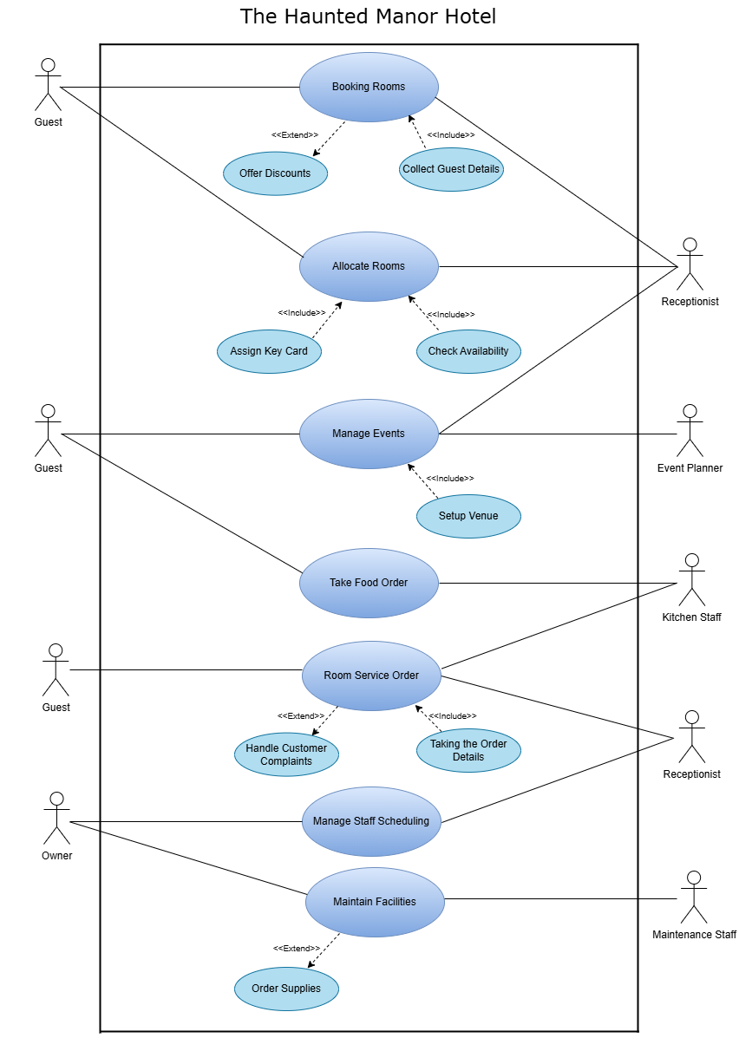

Activity Diagram

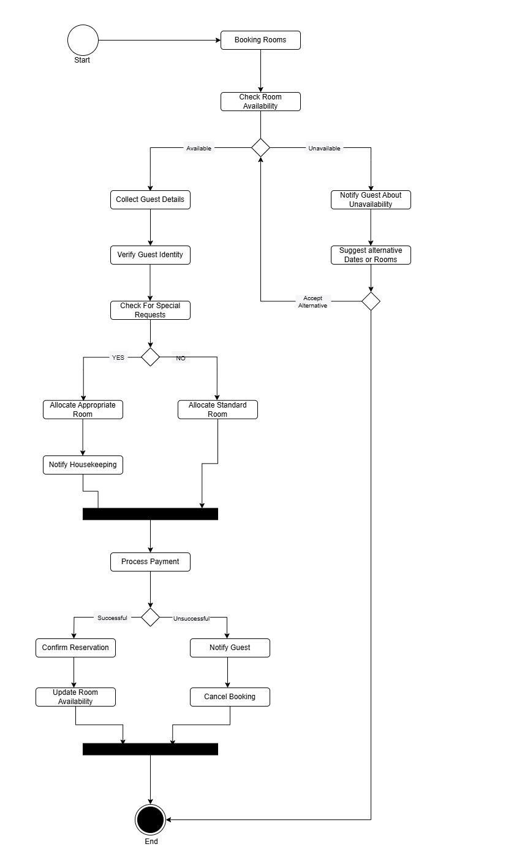

Textual Descriptions

Event Booking and Coordination Process at The Haunted Manor Hotel
Use Case Name | Manage Events
Description | Explains the procedures for booking a wedding, corporate function, or themed party at The Haunted Manor hotel. It guarantees that booking for such function is done correctly, that the required resources are allocated, and that other departments are notified in a way that avoids conflicts or double booking.
Actors | - Event Manager  - Customer  - Receptionist  - Head Chef  - Cleaning Staff
Pre-conditions | The customer has reached out to the hotel in reference to booking an event.
Post-conditions | The event is successfully scheduled and confirmed in the system.
Main Success Scenario | - Use Case begins with a customer contacts the hotel to request an event booking.  - The event manager checks availability in the system.  - If the requested date is available, the event manager registers the event with details. (Ex: event type, number of guests, and special requirements)  - The event manager assigns rooms and other required resources.  - The kitchen and cleaning staff are notified of event-specific needs.  - The receptionist updates the system with the event details.  - The event manager confirms the booking with the customer.  - The use case ends with the event successfully added to the event schedule.
Alternate Paths  Alternate Paths | 2aⅰ. No Availability on the Requested Date  ⅱ. The event manager informs the customer that the date is unavailable.  3a ⅰ. Customer cancel the event.  ⅱ. The event manager removes the booking from the system.  8a ⅰ. Customer Requests Changes After Booking.  ⅱ. The event manager updates the booking details.  ⅲ. The event manager sends notifications to relevant staff.  ⅳ. The hotel sends an updated confirmation to the customer.

Requirements

Functional Requirements

- Room Booking System
- Give customers the option to book online through the hotel’s website.
- Avoid double booking of rooms through real-time availability updates.
- In short, let staff assign and adjust room assignment based on their needs.
- Care for the event guests who are having overnight stays.

- Event Booking System
- Allow your wedding and event venues to be booked online.
- Control event scheduling to avoid overlaps and overbooking.
- Customization of event details, including catering & special requests.

- Food Ordering System
- There are things that staff and their supervisors can do today: Digitize restaurant, bar and room service orders.
- Different sources – be it the restaurant, bar, or room service send orders directly to the kitchen.
- Monitor food orders and delivery locations to prevent mix-ups.

- Housekeeping and Building Maintenance Management
- Auto-create the daily cleans based on guest check-out/stayover status.
- Inform staff of maintenance requests made by guests or management.

- Supplier and Inventory Management
- Monitor inventory levels of food supplies and other hotel resources.
- Enable automatic replenishment of supplies when levels run low. (altexsoft, 2022)
- Keep track of supplier transactions and pending payments.

- Training and Management of Staff and Scheduling
- Assign and monitor staff roles based on their responsibilities.
- Enable flexible role assignment for those that wear many hats.

- Financial and Billing System
- Issue bills for room bookings and event reservations.
- Keep track of payments and balances due.
- Incorporate various payment methods.

Non-Functional Requirements

- Performance Requirements
- The room booking should be processed by the system in 3 seconds. (As an example, food orders need to reach kitchen within 2 seconds or less from the time it has been ordered.)

- Usability Requirements
- The interface of the system needs to be intuitive for the customers and also for the staff involved.
- The staff should be able to learn how to use the system in less than 2 hours of training. (altexsoft, 2022)
- The system has to be support in desktop as well as mobile.
- Security Requirements
- The Best way to secure customers data is to encrypt all data.
- Features like booking and billing, or staff management, should only be accessible by authorized personnel. (altexsoft, 2022)
- Users need to be automatically logged off after 10 minutes of inactivity.
- Availability Requirements
- The system must be running non-stop 24/7 with 99.9% up-time. (altexsoft, 2022)
- Backups must be automatic and performed every 24 hours.
- Maintainability Requirements
- No more than 30 minutes of downtime for system updates.
- New functionalities must be given without big changes.
- Reliability Requirements
- Minor failure recovery should happen automatically without manual interference by the system. (altexsoft, 2022)
- If it fails, a failover system must revive services in under 10 minutes.

User Stories

1. Room Booking System
As a guest,
I want to book a hotel room online,
So that I can easily secure a room without needing to call or email the hotel.

2. Food Ordering System
As a chef,
I want to receive all food orders digitally from the restaurant, bar, and room service,
So that I can prepare meals efficiently without confusion or missing orders.

3. Housekeeping and Maintenance Management
As a housekeeper,
I want to receive an automatically generated list of rooms that need cleaning,
So that I can complete my tasks without relying on manual paper lists or verbal communication.

MoSCoW Analysis

MUST | - Make it possible for guests to make reservations online via the hotel's website.  - Prevent duplicate reservations by using real-time availability updates.  - Permit online reservations for your wedding and event locations.  - Manage event scheduling to prevent overbooking and overlaps.  - Send out invoices for reservations for events and rooms.  - Maintain a record of payments and outstanding amounts.  - Include a range of payment options.  - The system should process the accommodation reservation in three seconds.  - The system needs to have 100% uptime and run continuously around the clock.  - Only authorized staff should be able to access features like booking and paying.  - Encrypting all data is the most effective method of protecting client information.
SHOULD | - Permit employees to assign and modify rooms according to their requirements.  - event specifics, such as catering and special requests, can be customized.  - To avoid confusion, keep an eye on meal orders and delivery locations.  - Create the daily cleanings automatically based on whether guests are staying over or checking out.  - Notify employees of any repair requests from management or visitors.  - Keep an eye on the food supply and other hotel resource inventories.  - Turn on automatic supply replacement when low levels occur.  - Monitor supplier transactions and unpaid invoices.  - Assign and oversee employee roles according to their duties.  - Allow for flexible role assignment for people who have many responsibilities  .  - Both clients and the employees using the system must find the interface easy to use.
COULD | - Attend to those attendees who are staying overnight at the event.  - You can digitize orders for room service, bars, and restaurants today.  - New features must be provided without significant modifications.
WON’T | - Provide an entirely offline reservation system.  - In the first stage, create a specific mobile application for the system.

Lifecycle Options

When creating a new system for The Haunted Manor Hotel, selecting an appropriate Software Development Lifecycle (SDLC) is critical to ensuring the success of the project. There are two common lifecycle models that could be considered for this investigation.
- Waterfall Model
- Agile Methodology

- Waterfall Model
The Waterfall Model is a linear and sequenced methodology where steps are followed in fixed stages (for example: requirements analysis → system design → implementation → testing → deployment → maintenance). This is useful for projects with requirements that can be clearly defined from the beginning and are not expected to change substantially (Atlassian, 2024).
Which Allows for The Haunted Manor,
- Advantages:

- Having stages is an obvious and structured way to make progress.
- Applicable for projects with stable requirements (e.g., the reservation system).
- Its well-documented process makes maintainability and training easier.

- Disadvantages:

- Development is not an easy thing to change after its been started.
- Such fundamental flaws are often discovered only during late-stage testing, necessitating major rework. (A very long timeline for a usable system.)

- Agile Methodology

Agile development is iterative and incremental, with more frequent feedback and finetuning. Agile generally addresses frameworks such as Scrum or Kanban, which includes the following: (Brush and Silverthorne, 2022)

- Sprint Planning – Determining work cycles of duration (2-4 Weeks)
- Development and Testing
- User Feedback & Review – Stakeholder Involvement at Each Iteration
- Deployment & refinement — Deliver usable bits and iterate.

Which Allows for The Haunted Manor,

- Advantages:
- Frequent feedback allows for quick adjustments to meet business needs.
- Higher flexibility to accommodate changes in booking systems and operations.
- Early working versions reduce the risk of failure.

- Disadvantages:
- Requires active participation from stakeholders (Gwen, Owain, and staff).
- May lead to scope creep if requirements continuously change.
- Less documentation compared to Waterfall.

When both models are compared, Agile is the more appropriate choice for The Haunted Manor as it allows for flexibility and an iterative approach, enabling the design of the system according to its real-world use. Someone may prefer a hybrid approach, applying the Waterfall Model for the early waterfall portions for fixed initial planning (Kirvan and Lutkevich, 2022) and core system plumbing (e.g., DB design) and Agile for features and iteration. This would provide The Haunted Manor Hotel with an efficient and realistic system that deals with its operations while providing a balance between structured planning and adaptability.

The Role of the User

The Importance of Communicating with Users During the Software Development Lifecycle.

Every software requirement is based on a clear outline of business goals. Effective communication with all users covering all the stages of SDLC is important to ensure that the final system is useful and provides value to the business. Users are all stakeholders that can either end up using the system like end users, the management, or the technical people responsible for making the system work (Abidi, 2023). Not considering user participation results in low efficiency and poor acceptance of an application that requires expensive rework. (Bin saif, Almohawes and Mohd Jamail, 2021)

Importance of User Communication Across SDLC Phases;

- Requirement Gathering & Analysis
Communication throughout this stage guarantees that developers record precise and comprehensive requirements. Users share their knowledge on desired features and current issues. Clear requirements are elicited through the use of techniques including focus groups, questionnaires, and interviews (Abhijeet Dinkar Patkar, 2021). 60% of software project failures are attributed to inadequate or inaccurate specifications, according to Sommerville.
(Hossain, 2023)
User communication is essential for The Haunted Manor Hotel to comprehend problems like:
- Inefficient resource allocation and duplicate reservations.
- The absence of a unified mechanism for ordering food.
- The procedure of manually assigning rooms and cleaning.
- A system might not be able to address these inefficiencies without user participation.

- System Design

All workflows, wireframes, and system prototypes are checked for validation with the users. This constant feedback guarantees that there are no usability issues or concerns and that the design meets expectations. (Abidi, 2023), one of the most important usability principles is user-centered design as it resolves ambiguity and improves system acceptance.
This phase will include interviewing the event managers, kitchen staff, and receptionists within The Haunted Manor to understand if this system will help improve their workflow without disrupting their normal business processes.

- Development & Implementation
Active engagement with the user eliminates the chances of misinterpretation of requirements and ensures that new features integrate seamlessly with current business processes. The combination of continuous development and frequent user engagement are essential for Scrum practices (Abidi, 2023).

- Deployment and Testing

Participant users are guaranteed to obtain desired results during User Acceptance Testing (UAT) if the developed system works in real-life use cases. IEEE guidelines (IEEE 829-2008) mention that before implementation, user testing helps in pinpointing significant usability and functionality challenges.
The following things should be t for The Haunted Manor Hotel:

- The booking system prevents double bookings.
- The kitchen ordering system correctly routes orders.
- New features may create new problems that are not identified during preliminary testing, which will require expensive fixes.

- Maintenance & Feedback
Distributive communication helps in ensuring that new bugs, usability issues, and new features are incorporated within the necessary limits. There needs to be a system for capturing and enforcing changes to promote improvements (Pressman & Maxim, 2020).

References

- Abhijeet Dinkar Patkar (2021). Communication is an essential building block of relationship development. Same way Communication is the most important part of software development. [online] Linkedin.com. Available at: https://www.linkedin.com/pulse/importance-communication-program-project-life-cycle-patkar [Accessed 7 Feb. 2025].

- Abidi, A. (2023). The Role of Communication in Software Development. [online] Medium. Available at: https://ayoub3bidi.medium.com/the-role-of-communication-in-software-development-2dbeb6cbe38c [Accessed 7 Feb. 2025].

- altexsoft (2022). Non-functional Requirements: Examples, Types, How to Approach. [online] AltexSoft. Available at: https://www.altexsoft.com/blog/non-functional-requirements/ [Accessed 7 Feb. 2025].

- Atlassian (2024). Waterfall Methodology for Project Management. [online] Atlassian. Available at: https://www.atlassian.com/agile/project-management/waterfall-methodology [Accessed 7 Feb. 2025].

- Bin saif, N., Almohawes, M. and Mohd Jamail, N.S. (2021). The impact of user involvement in software development process. Indonesian Journal of Electrical Engineering and Computer Science, 21(1), p.354. doi:https://doi.org/10.11591/ijeecs.v21.i1.pp354-359.

- Brush, K. and Silverthorne, V. (2022). What is Agile Software Development (Agile Methodologies)? [online] TechTarget. Available at: https://www.techtarget.com/searchsoftwarequality/definition/agile-software-development [Accessed 7 Feb. 2025].

- Hossain, M.A. (2023). Software Development Life Cycle (SDLC) Methodologies for Information Systems Project Management. International Journal For Multidisciplinary Research, 5(5). doi:https://doi.org/10.36948/ijfmr.2023.v05i05.6223.

- Kirvan, P. and Lutkevich, B. (2022). What is waterfall model? - Definition from WhatIs.com. [online] SearchSoftwareQuality. Available at: https://www.techtarget.com/searchsoftwarequality/definition/waterfall-model [Accessed 7 Feb. 2025].

- Kruger, G. (2020). What Are Non Functional Requirements — with Examples. [online] Perforce Software. Available at: https://www.perforce.com/blog/alm/what-are-non-functional-requirements-examples [Accessed 7 Feb. 2025].

- Pressman, R.S. and Maxim, B.R. (2020). Software engineering : a practitioners approach. New York, Ny: Mcgraw-Hill Education.

- Roskar, K. (2024). What are non-functional requirements? Detailed guide + examples | DECODE. [online] DECODE. Available at: https://decode.agency/article/non-functional-requirements-examples/ [Accessed 7 Feb. 2025].

- SA Main Site. (n.d.). IEEE SA - IEEE 829-2008. [online] Available at: https://standards.ieee.org/ieee/829/3787/ [Accessed 7 Feb. 2025].

